1. Write a blog on Difference between HTTP1.1 vs HTTP2

HTTP 1.1 uses plain text to encode and transmit data. Though it is easy for humans to read and understand the data, it can be less efficient than a binary protocol.

HTTP 2 uses a series of binary codes to encode and transmit data rather than plain text. Binary protocols are generally more efficient than text-based protocols because they can data more compactly.

|  |  |  |
| --- | --- | --- |
|  | **HTTP 1.1** | **HTTP 2** |
| **Development** | It was developed in the year 1997 | It was developed in the year 2015. |
| **Compression** | It compresses data by itself. | It uses HPACK for data compression. |
| **Binary Protocol** | A text-based protocol uses plain text to encode and transmit data. | It works on the binary protocol as a series of binary codes encode and transmit data rather than plain text. |
| **Security** | The client sends a request to a server, and the server sends a response back to the client. | A different underlying [protocol called Secure](https://cheapsslweb.com/blog/an-ultimate-guide-on-secure-shell-protocol) Remote Protocol 2 (SRP2) establishes a secure connection between a client and a server. |
| **Multiplexing** | A separate connection is established for each request and response, which can add overhead and latency to the communication process. | It allows multiplexing so multiple requests and responses can be sent over a single connection. |
| **Buffer Overflow** | HTTP 1.1 cannot handle buffer overflow vulnerabilities due to the lack of sufficient measures. | HTTP 2 includes measures to prevent buffer overflow vulnerabilities. |
| **Performance** | HTTP 1.1 does not include any in-built features, so the performance it delivers is less efficient. | HTTP 2 is designed to be more efficient and performant than HTTP 1.1. This is because HTTP 2 includes several features like multiplexing, binary protocol and header compression. |

## Which Browser Supports HTTP 2 and HTTP 1 ?

Most modern web browsers support HTTP 1.1 and  HTTP 2 including [Google Chrome](https://cheapsslweb.com/blog/how-to-fix-err-ssl-version-interference-error-in-chrome), Mozilla Firefox, Apple Safari, Microsoft Edge, and Opera.

However, the HTTP version might vary based on the version of the browser, and some older versions may not support it. So it all comes down to the operating system, as well as the specific configuration of the browser.

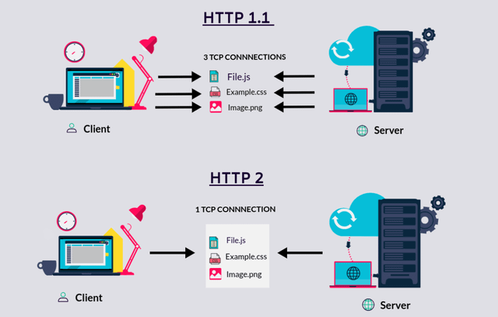

2. Write a blog about objects and its internal representation in Javascript

Objects in Java Script are not similar to any other objects in any other languages. Other languages like C,C++,Java have their own object necessity

What is a JavaScript object?

A JavaScript object is a collection of unordered properties. Properties can usually be changed, added, and deleted, but some are read only.

Objects in JavaScript are very much similar to the objects in real-life. We can see a lot of Objects around us in this real world, each with its own set of properties. For instance let us take a table in the real world, it has its own properties like height, width, and length etc. Similarly all the Objects in the JavaScript are associated with its own set of properties.  
  
This can be represented in JavaScript objects as below :

var mostExpensivefoundation = {

'name' :'Clinique',

'brand' :'Superbalanced',

'model' : '1 oz/30 ml, 04 Cream Chamois',

'shade' : 'Beige',

'quantity' : '30ml',

'finish' : 'natural'

}

We can see that there are all the properties in the image being added to the Object “mostExpensivefoundation”. The properties are provided as key value pairs in JavaScript. Here “name” is one of the keys and “Clinique” is its value. It is important to note that all of these are Case-Sensitive in JavaScript. An Object can have a number of data types inside it as values. It can have numbers, string, arrays and even another Object inside it.

3. Read about IP address, port, HTTP methods, MAC address

**IP Address**

An IP address is a unique numerical label assigned to each device connected to a computer network, such as the internet. It acts as a virtual address that allows devices to communicate and identify each other on the network. There are two main versions of IP addresses:

* **IPv4:** The older version, consisting of four sets of numbers between 0 and 255, separated by periods (e.g., 192.168.1.1).
* **IPv6:** The newer version, with a more complex format using hexadecimal numbers and colons (e.g., 2001:0db8:85a3:0000:0000:8a2e:0370:7334).

**Port**

A port is a virtual communication channel associated with an IP address. It allows different applications or services running on the same device to receive and send data independently. Imagine an IP address as a building with multiple doors (ports), each leading to a specific apartment (application or service). Common port numbers include:

* **80:** HTTP (web traffic)
* **443:** HTTPS (secure HTTP)
* **21:** FTP (file transfer)
* **25:** SMTP (email)

**HTTP Methods**

HTTP methods are specific commands sent within an HTTP request to instruct the server on how to handle the request. These methods define the desired action on the server-side, such as retrieving data, creating new resources, or updating existing ones. Some common HTTP methods include:

* **GET:** Retrieves data from the server, often used for fetching web pages or resources.
* **POST:** Submits data to the server, typically used for submitting forms or creating new data.
* **PUT:** Updates existing data on the server.
* **DELETE:** Removes data from the server.
* **PATCH:** Applies partial modifications to data on the server.

**MAC Address**

A MAC address (Media Access Control address) is a unique hardware identifier assigned to each network interface card (NIC) in a device. It’s used at the data link layer of the OSI model to ensure proper delivery of data frames within a local network segment. Unlike IP addresses, which can be dynamic and change, MAC addresses are typically burned into the hardware and remain static.

**Relationships between these concepts:**

* **IP address and port:** Together, they uniquely identify a specific application or service running on a device on the network.
* **IP address and MAC address:** An IP address is assigned to a logical network interface, while a MAC address is assigned to the physical NIC hardware. A device can have multiple MAC addresses but only one primary IP address for each network interface.
* **HTTP methods and ports:** Specific HTTP methods are often associated with specific ports. For example, GET and POST requests for web pages typically use port 80 (HTTP) or 443 (HTTPS).